**Name:**

**Dawood Sarfraz**

**Roll no:**

**20p-0153**

**Section:**

**BSCS-9A**

**Assignment no 4:**

**Build Automation (Pre-Processors)**

**Submitted to:**

**Dr. Omar Usman Khan**

**1. What happens if you rename the file to my_header_file.txt and include this file only?**

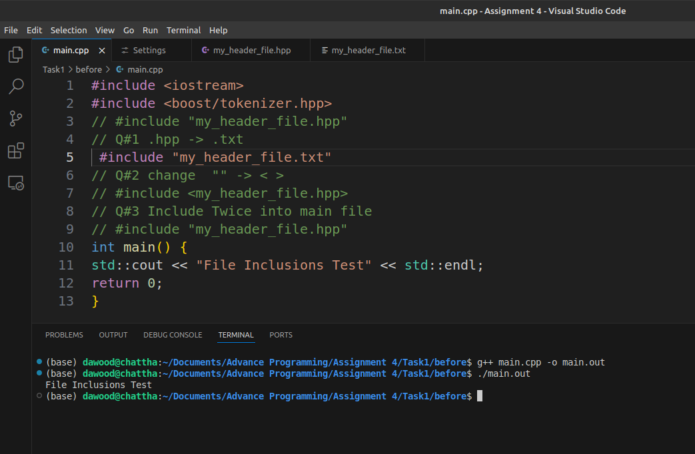

***2. What happens if you change “” to < > just like iostream is enclosed in <>.***

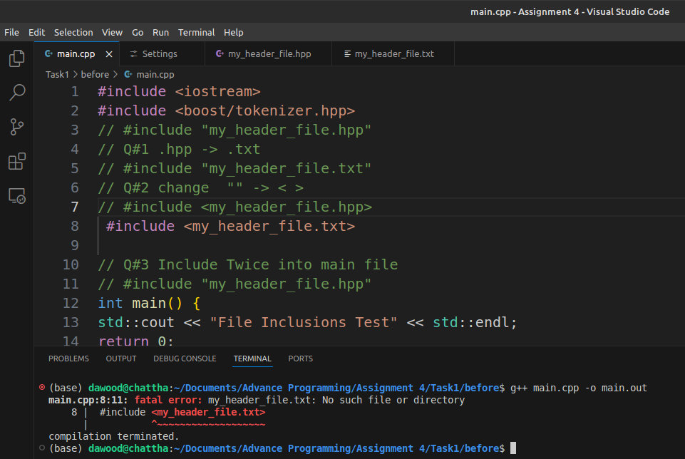

***#Practice***

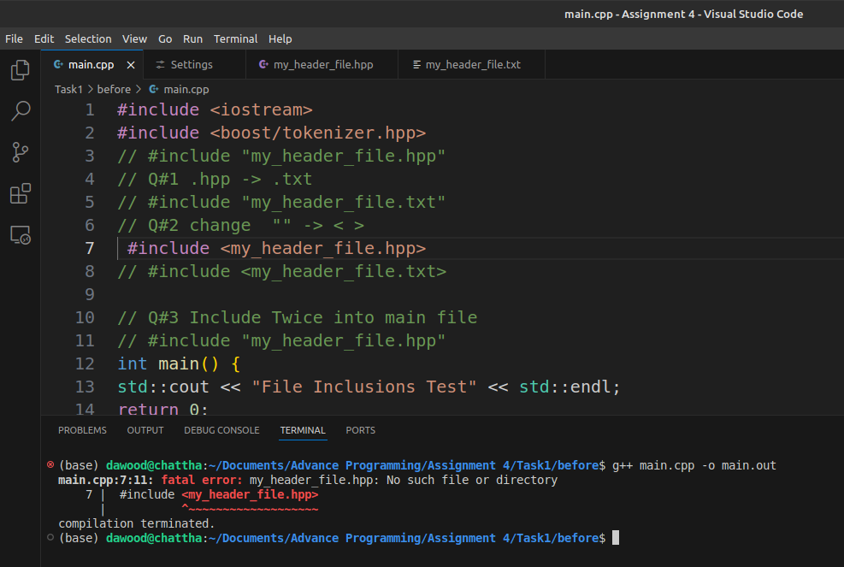

***3. What happens if you do #include “my_header_file.hpp” twice in your code?***

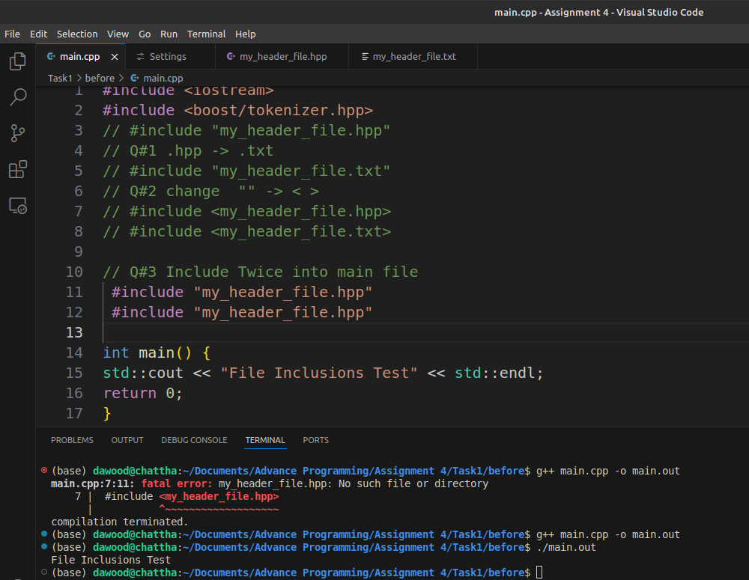

***# Practice***

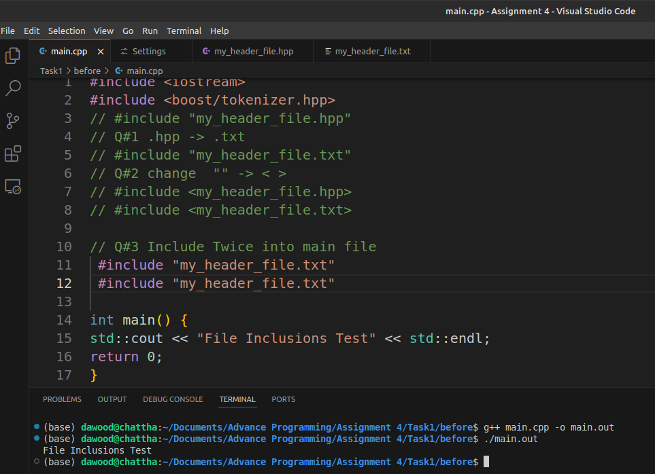

***# Practice***

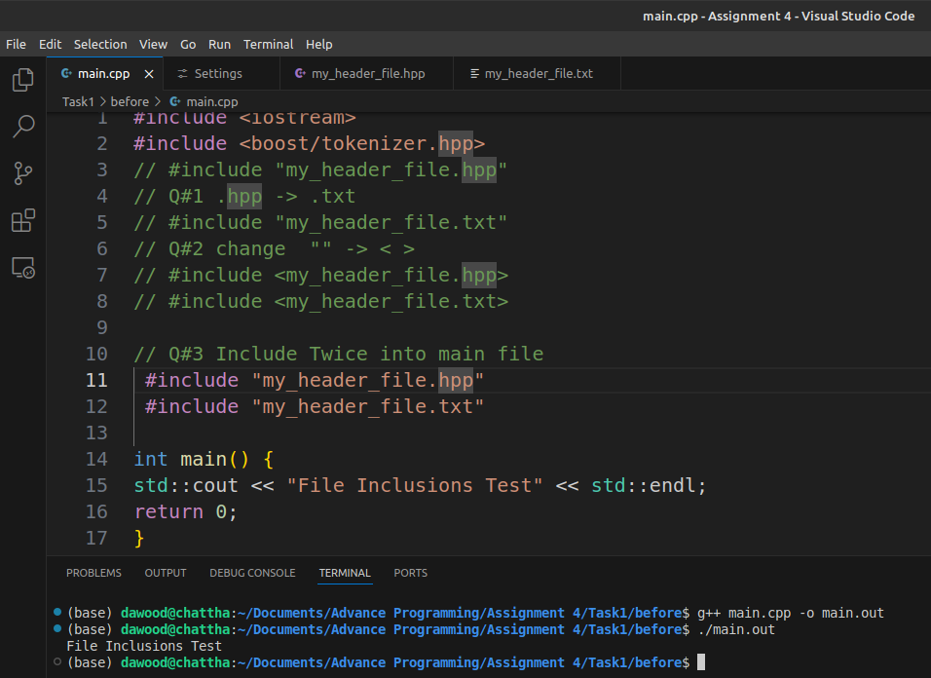

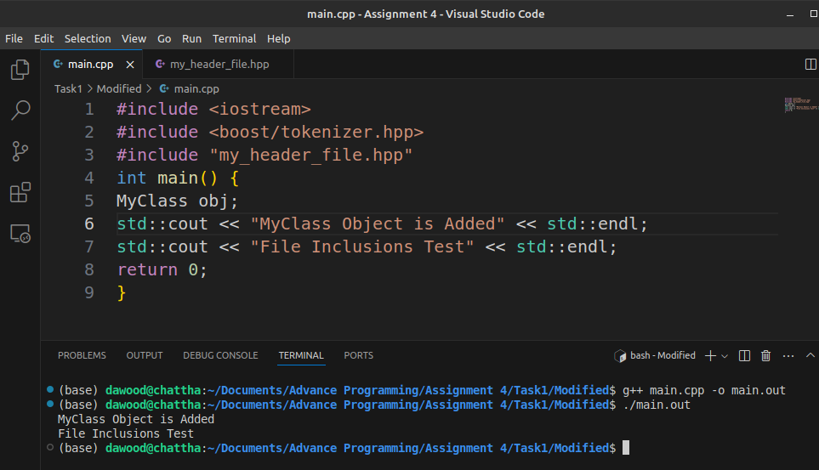

***4. What happens if you do #include “my_header_file.hpp” twice in your code?***

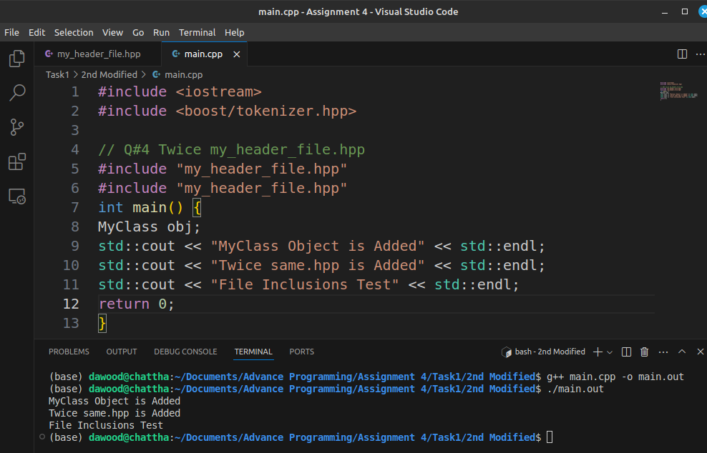

***5. What happens if you do #include “my_header_file.hpp” twice in your code?***



***6. What happens if you rename #ifndef to #ifdef?***

